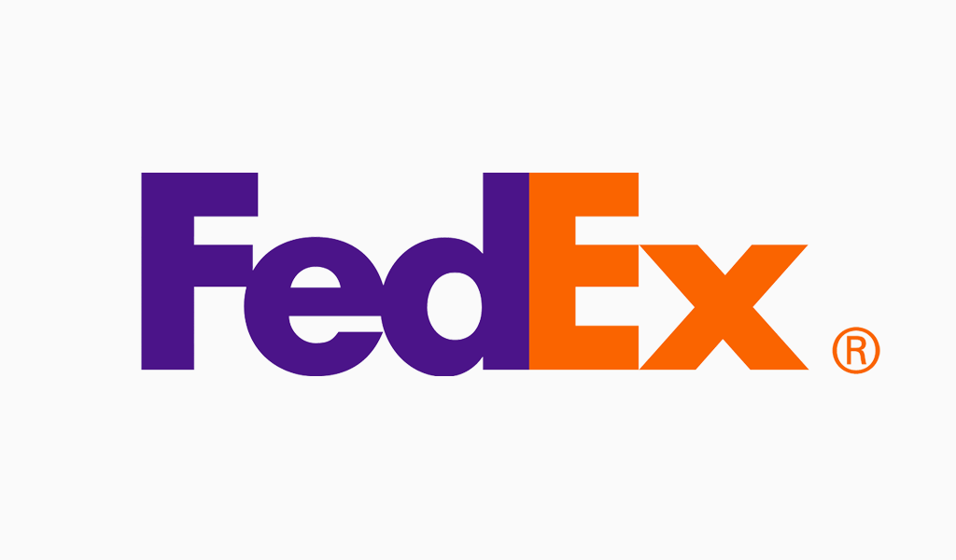

Presented By :

ABID NOUR

CONTENTS

I- VISUAL IDENTITY STANDARDS

1. LOGO & COLORS

2. LOGOS & VERSIONS

3. LOGO HISTORY

4. TYPOGRAPHY

5. USES

II- MODELING 3D OBJECTS

1. 3D LOGO
2. FEDEX CUP

3. TRUCK

4. BOOK

5. PACKAGE

III- ANIMATION

**VI- PACKAGING**

**I- VISUAL IDENTITY STANDARDS**

1. LOGO & COLORS

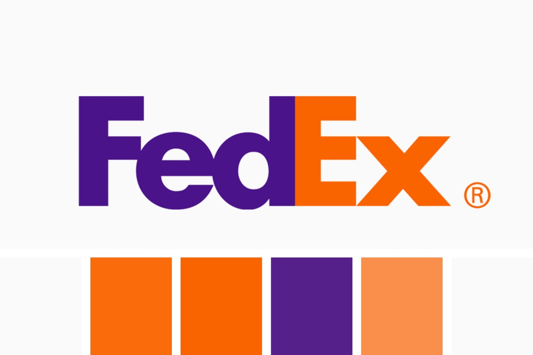

COLOR : Blanc Safety Orange Blue Violet Pumpkin

Blaze Orange Color Wheel

HEXAGONE : #FAFAFA #F96300 #4A1388 #F97B2A

RVB : 250, 250, 250 249, 99, 0 74, 19, 136 249, 123, 42

2. LOGOS & VERSIONS



3. LOGO HISTORY

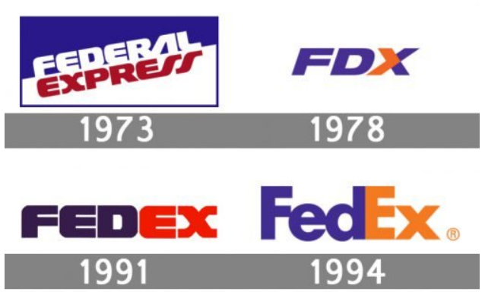

4. TYPOGRAPHY

**Font family : Sans Serif**

**Bold font**

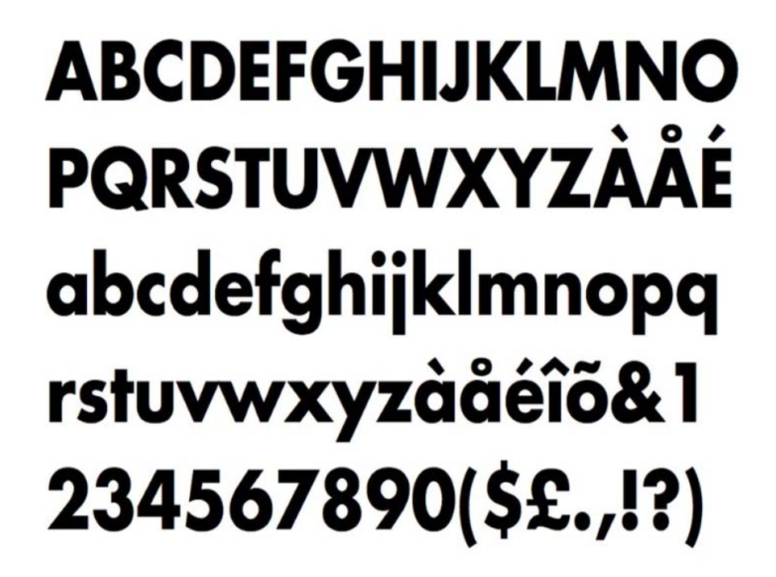

5. USES

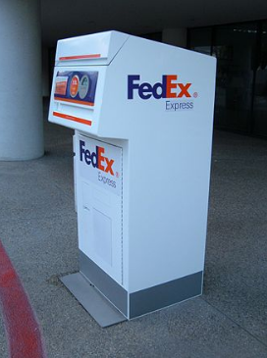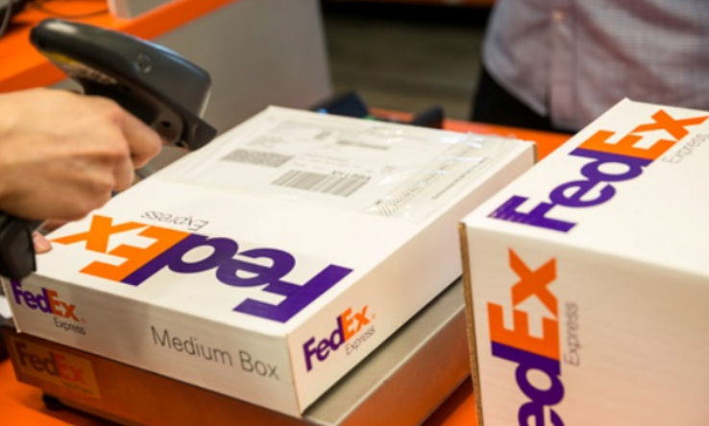

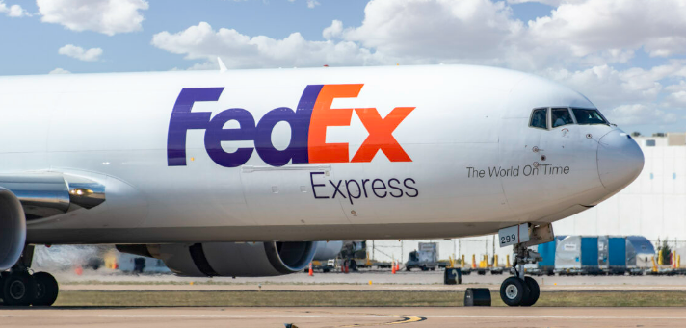 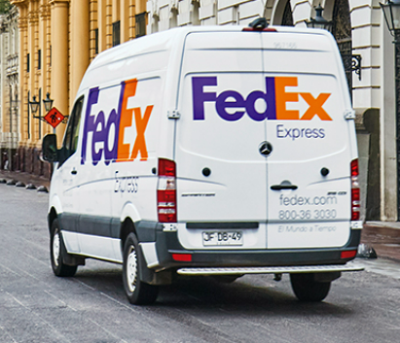

II- MODELING 3D OBJECTS

1. 3D LOGO 2. FEDEX CUP

 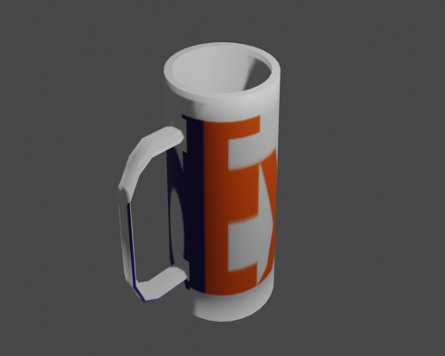

3. TRUCK 4. BOOK

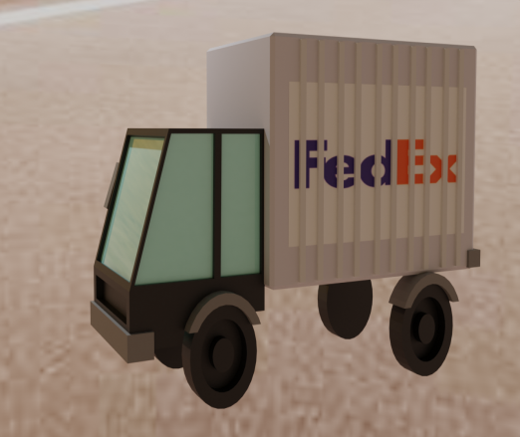 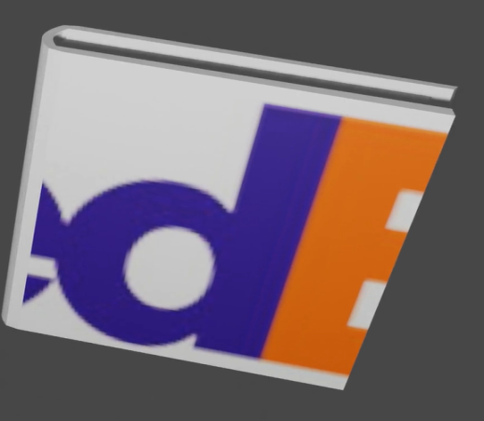

5. PACKAGE

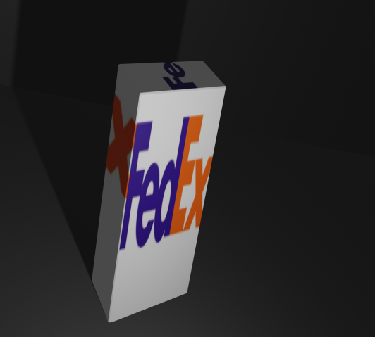

III- ANIMATION

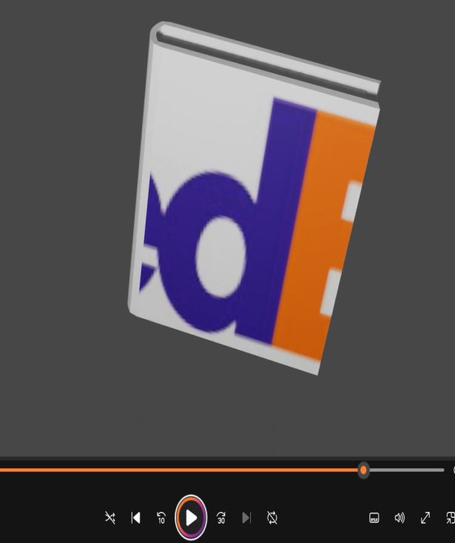 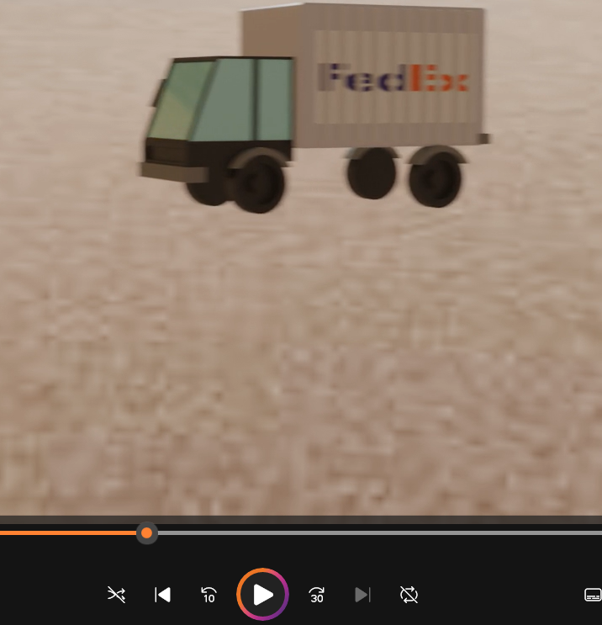

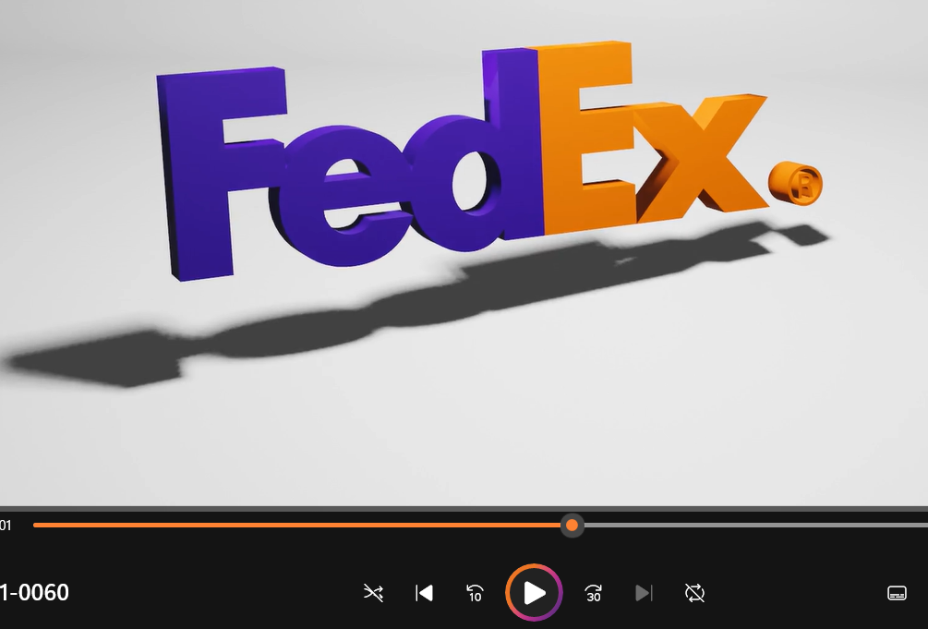

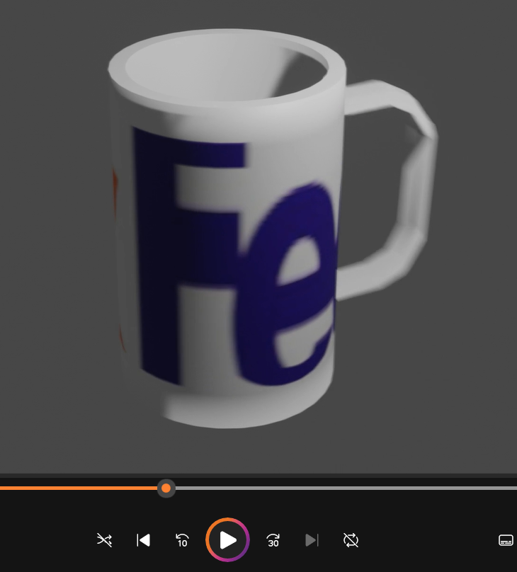

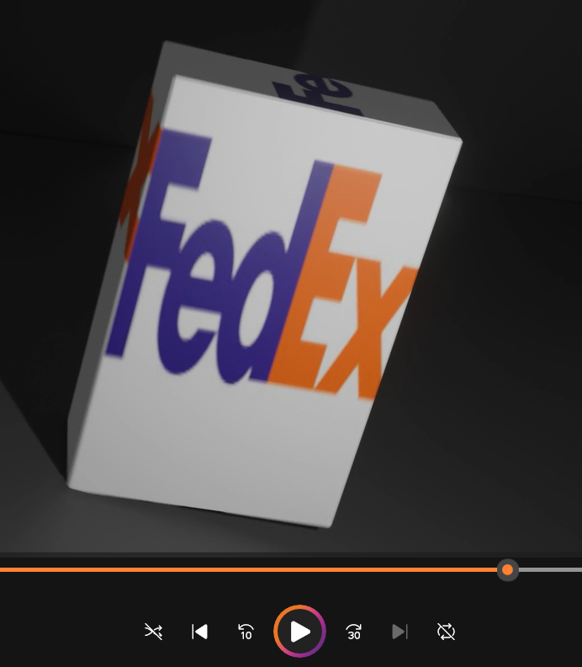

VI- PACKAGING

